Soldier Nav Mesh Links

Introduction

This tutorial discusses the uses of some of the Nav Mesh links used to get soldiers to perform activities such as jumping over walls or using stairs. The tutorial used for this discussion is NavMeshLinks_Soldier01.

Nav Mesh Links

Setting up Nav Mesh Links

A Nav Mesh is the AINavMesh object with the brushes and links that comprise it placed under its node in the Node Tree. Nav Mesh Links can only be one brush, which is placed under the link node. Figure 1 shows a Nav Mesh and its nodes in the level editor.

Figure 1:

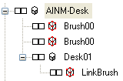

AINM-Desk is the Nav Mesh object. There are two brushes under the node (named Brush00). Desk01 is a link object, with the brush that comprises it (LinkBrush) placed under it in the node. The Nav Mesh determines where the characters can move in the game, but the brushes comprising it are invisible. If you accidentally place a prefab under the Nav mesh node it will not show up in game (not that I’ve ever done this, but .. I’ve heard of it happening…).

Two parameters of the Nav Mesh links that are commonly used are StartDisabled and SmartObject. StartDisabled allows the link to be inactive until enabled. This is useful if you have a link running through an area that you don’t want enemies to access until a condition is met. Script commands that enable and disable the link are Enable and Disable. A script that enables (allows a link to be used) would be

msg LinkName enable;

The SmartObject determines which animation the soldiers will play when using the link.

Examples of the commonly used links are given below.

AINavMeshLink

This link does not have any special animations used with it, but it is useful for making links that you want to turn on or off. The most common use for this is if you have the link running through a door and you don’t want enemies to move through the door until it is open. The link starts disabled, with the StartDisabled parameter set to True. After the door opens it is enabled so enemies can run through.

AINavMeshLinkDiveThru

The AINavMeshLinkDiveThru object has two smart objects that are used for soldier navigation, Dive Thru and DiveOverDesk.

DiveThru Smart Object:

DiveThru has the soldier dive over an object and roll before standing up on the other side. Figure 1 shows the setup of the AINavMeshLinkDiveThru object in the level editor.

Figure 1

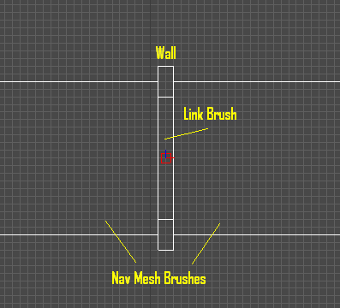

The Nav Mesh brushes extend on either side of the wall. The wall is 20 cm wide, and the link brush fits inside it. Some useful tips for using the DiveThru smart object are:

- When diving over a wall it is best to have the wall 100 cm or less high. Make the link 20 cm wide and place it in the wall. The start of the link brush determines where the animation starts. If the link brush extends outside the wall or the wall is higher than 100 cm the soldier will appear to clip through the wall during the animation.
- The position and facing of the link object have no effect on the distance or height jumped.
- The link works in both directions and will remain valid until disabled.

DiveOverDesk Smart Object:

Unlike the DiveThru smart object, when this smart object is used the link appears to only work once. Once a soldier dives over a desk he will not dive over it again.

Figure 2 shows the link in the level editor. The link brush extends approximately 10 cm beyond the length of the desk. The soldier can leap over the desk from either side, but once the link is used the soldier will not use it again.

Figure 2: Link using the DiveOverDesk smart object.

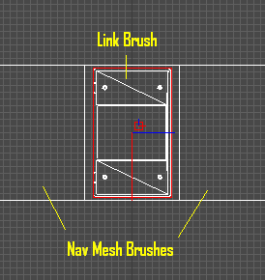

AINavMeshLinkJump

The AINavMeshLinkJump object is used to get soldiers to jump down to a lower level. There are two Smart Objects used with this, JumpDown and JumpRail.

When using this link it is important that there be no Nav Mesh brushes directly underneath the link brush. If there are brushes underneath the link brush, or if the Nav Mesh accidentally has some of its brushes overlapping each other, then soldiers will fall through the floor when using the link with the JumpDown smart object. The JumpRail smart object seems to be more forgiving of Nav Mesh errors.

JumpDown Smart Object:

This Smart Object has the soldier play an animation of running up to a ledge and jumping down. Figure 3 shows a link with using the JumpDown smart object as seen in the level editor. The link brush is highlighted.

Figure 3: Link using the JumpDown smart object as seen in the level editor.

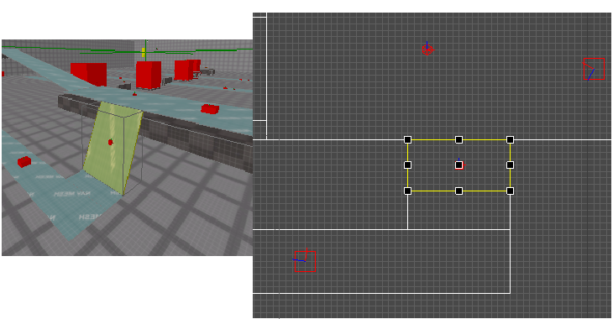

When using this smart object it is important to avoid Nav Mesh errors. This smart object is more sensitive to errors than the JumpRail smart object. There should be no Nav Mesh brushes underneath the link, and the link should start at the edge of the ramp. If the Nav mesh accidentally extends beyond the edge soldiers will sometimes rapidly fall to the ground before reaching the link or fall through the floor when using it.

A good length for the link brush is 50 cm, though the link brush in Figure 3 is 80 cm wide and works fine.

JumpRail Smart Object:

The JumpRail smart object has the character play an animation of leaping over a rail. This link works best if the soldier jumps over a rail to a lower level. The animation is designed for a rail height of 95 cm.

Figure 4 shows a view of the Jump Rail link in the level editor. The link brush is highlighted. The beginning of the link brush is at the edge of the rail. At this position the hand appears to rest on the rail as the soldier jumps over it.

The width of the link is not critical, as the length of the jump is determined by the animation. However, if the link brush is 100 cm wide and extends past the length of the animation, then the character will appear to pop forward after landing so he is at the end of the brush. It is probably better to have the length of the link brush short (ie. 20 cm), as it is in the tutorial example.

Figure 4: JumpRail link as seen in the level editor.

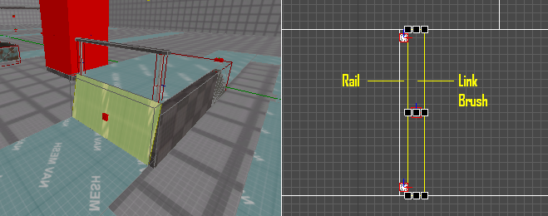

Figure 4: JumpRail link in the level editor. The link brush is highlighted and is 20 cm wide.

AINavMeshLinkJumpOver

This link has only one smart object used for soldiers, and that is JumpOver. This link plays an animation that has the soldier leap and land with both feet together.

Unlike the other links, with this one the placement of the link object and the link brush determines how high and how far the soldier moves. While the soldier plays an animation the height of his feet go to the height of the link object, and the distance traveled is the length of the link brush. The link object placement effects only the height of the jump – the highest point always occurs at the center of the link brush length.

This link can be used to have soldiers jump up or down. If the link brush is long the soldier will appear to jump in slow motion, though the exact details of when this happens are uncertain.

AINavMeshLinkStairs

This is used to get soldiers to walk up and down stairs. The animation used for this is designed for stairs 20 cm high and 30 cm wide. Soldiers will use the center of the link. If you want to have more than one character use the stairs and not have them line up behind each other then it is necessary to have two or more narrower links on the stairs.

Figure X shows a side view of the Stairs link. The top should be even with the edge of the first step, and the bottom should extend out 30 cm from the edge of the bottom step. The Nav Mesh is 20 cm above the ground.

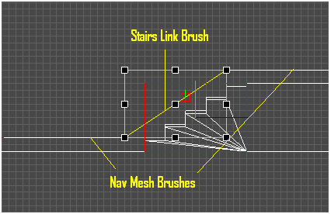

tutorial level Walkthrough

In this level standing on the square boxes spawns soldiers that are scripted to run around paths with different Nav Mesh Links. A description of what each path has is given below.

Path with JumpOver and JumpDown Links

The first path contains AINavMeshLinkJumpOver and AINavMeshLinkJump objects. Of interest to note here is the fact that the player can appear to jump up or down using the JumpOver link. Also, the longest jump appears to happen in slow motion, though the exact factors necessary to get this to happen are unknown.

It should also be noted that a soldier will not always take the shortest route to a GoTo node. The figure shows the path as seen in the level editor. The soldier will spawn in front of Node 3 and move to Node 1. After Node 1 he works his way around by visiting Node 2, Node 3, and Node 4 in order. After Node 4 he returns to Node 1 and the cycle repeats.

The soldier will not always take the shortest route from Node 3 to Node 4. Instead of using the JumpDown link he will use the two JumpOver links to geo from 3 to 4. If you wanted to force the soldier to use the JumpDown link you could disable a JumpOver link at Node 3, then enable it again at Node 4.

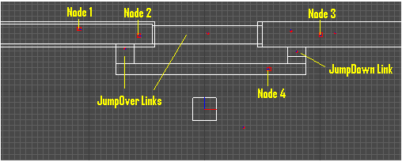

Path with one AINavMeshLinkJumpOver Link

The next path simply has a soldier jump over a wall. Here you should notice that the height of the jump depend upon the positions of the link object – the soldiers feet will be as high as this is. The length of the jump equals the length of the link brush. The position of maximum height in the jump will always be the center of the link brush. The position of the link object only determines the jump height, and does not effect where the maximum height is located.

The animation for this jump is not ideal – the soldier seems to stop before jumping. There is not a good blend between the run and jump animations, and the stop occurs when the animation must change from run to jump.

Paths with AINavMeshLinkDiveThru

This link object has two Smart Objects that are used for soldiers, DiveThru and DiveOverDesk. Of interest with these paths is the fact that the soldier will run back and forth using the DiveThru link, while he will only dive over the desk once. It does not matter which side the soldier comes from. Once the link with a DiveOverDesk Smart Object is used it is disabled.

Path with Stairs, JumpRail, and Link links

This path has the soldier run up stairs, jump over a rail, and then run to the stairs again. Here it was necessary to use an AINavMeshLink object to force the soldier to follow this path. If this was not used then the soldier would not use the stairs to go from Node 1 to 2. Instead of using the Stairs and JumpRail links he would take the longer ground route.

The figure shows this path in the level editor.

At GoTo Node 2 the link (named Stairs-Link01) is activated with the command

msg Stairs-Link01 enable;

At Node 3 the link is disabled, forcing the soldier to use the Stairs and JumpRail links.

msg Stairs-Link01 disable;

